Login to the supplier maintenance portal using AD account

<https://optimus.st.optimus.cig.local/adk/suppliermaintenance/en/#d090a962-079b-4d94-b6e8-f7d875ff1a0c>

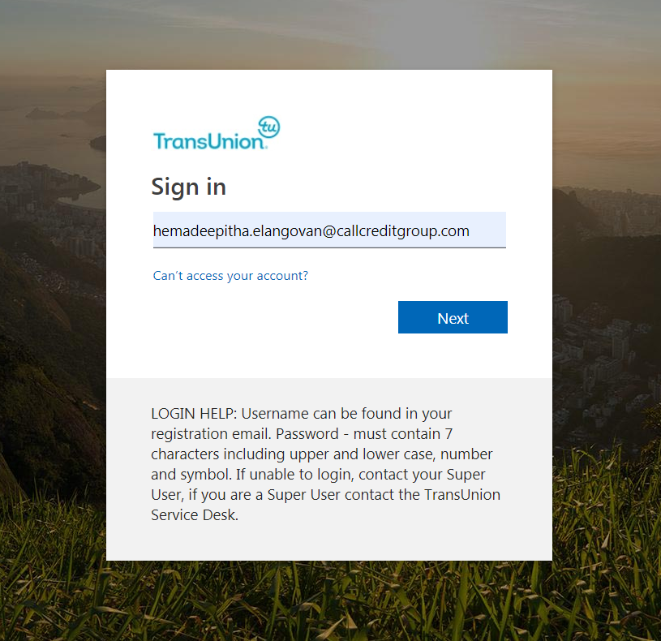

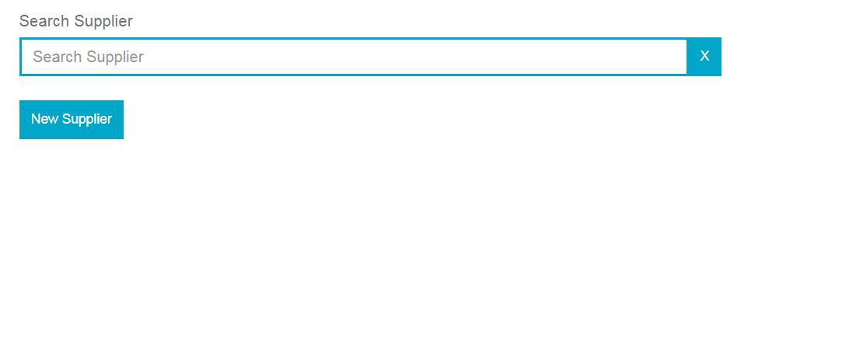

Click New Supplier

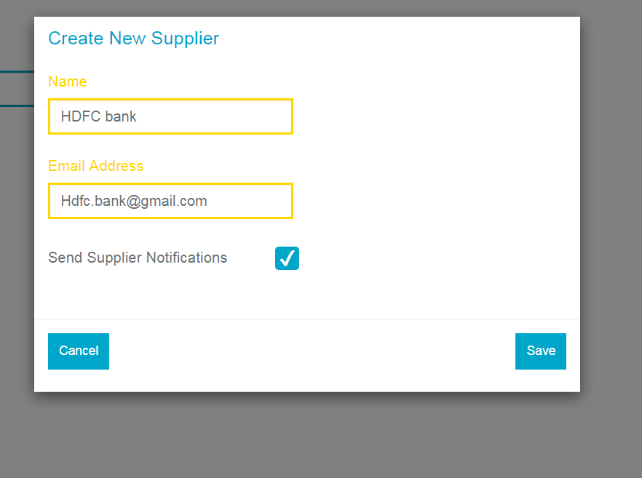

Click Save

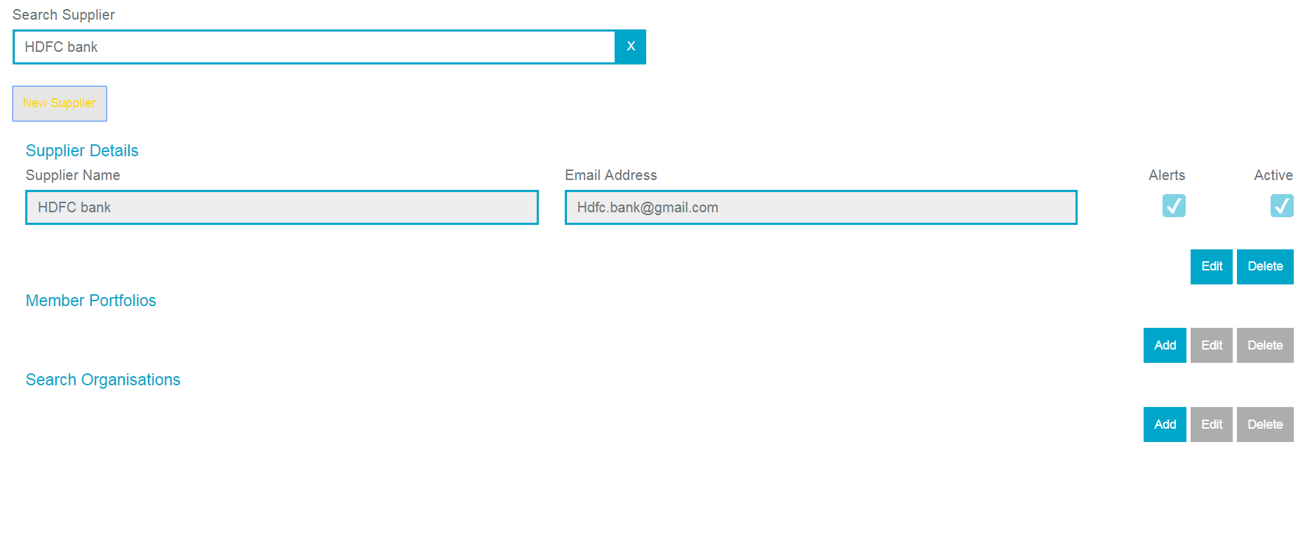

Click Add button under Member portfolio

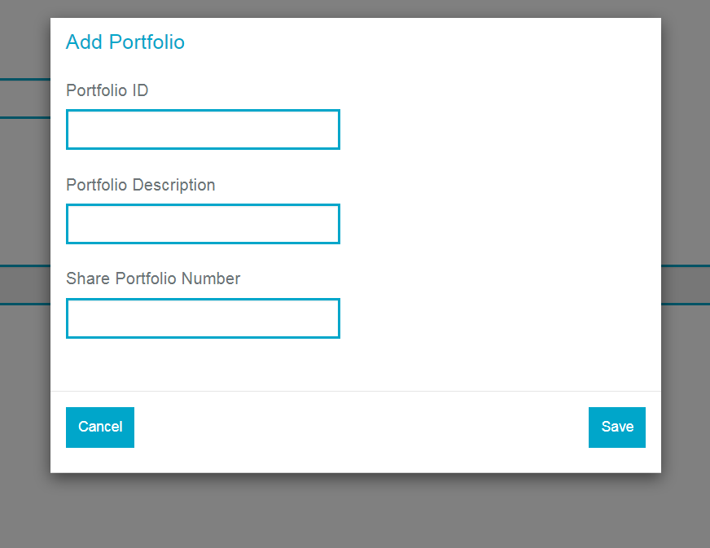

Fill all the fields

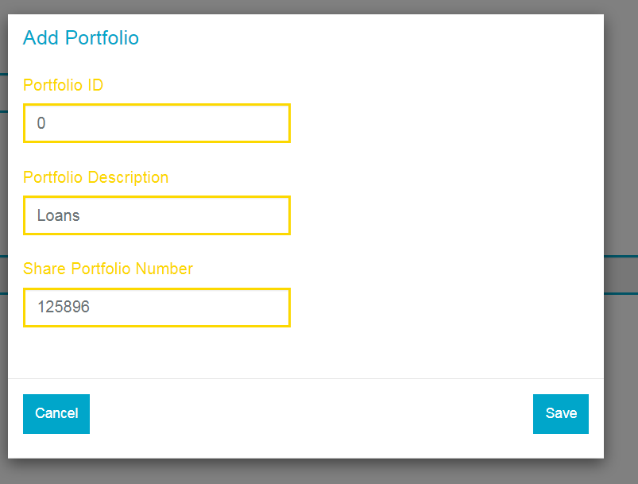

Click Save

Error:

